Assignment 3

1. <http://studentweb.ewu.edu/eglushchenko/ShowProduct.php>

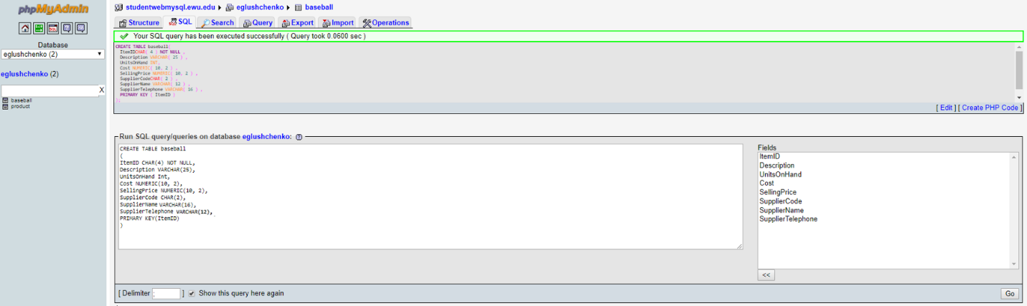

INSERT INTO baseball VALUES(3663,'Baseball Cap', 30, 10.15, 18.76,'LG','Logo Goods','517-555-3853');

INSERT INTO baseball VALUES(3683,'Coasters (4)', 12, 7.45, 9.00,'BH','Beverage Holders','317-555-4747');

INSERT INTO baseball VALUES(4563,'Coffee Mug', 20, 1.85, 4.75,'BH','Beverage Holders','317-555-4747');

INSERT INTO baseball VALUES(5923,'Jacket', 12, 44.75, 54.95,'LG','Logo Goods','517-555-3853');

INSERT INTO baseball VALUES(5953,'Short', 10, 14.95, 19.95,'AC','Al Clothes','616-555-9228');

INSERT INTO baseball VALUES(6189,'Sport Towel', 24, 3.25, 6.75,'LG','Logo Goods','517-555-3853');

INSERT INTO baseball VALUES(6343,'Sweat Shirt', 9, 27.45, 34.95,'AC','Al Clothes','616-555-9228');

INSERT INTO baseball VALUES(7810,'Tee Shirt', 32, 9.50, 14.95,'AC','Al Clothes','616-555-9228');

INSERT INTO baseball VALUES(7930,'Coffee Travel Mug', 11, 2.90, 3.25,'BH','Beverage Holders','317-555-4747');

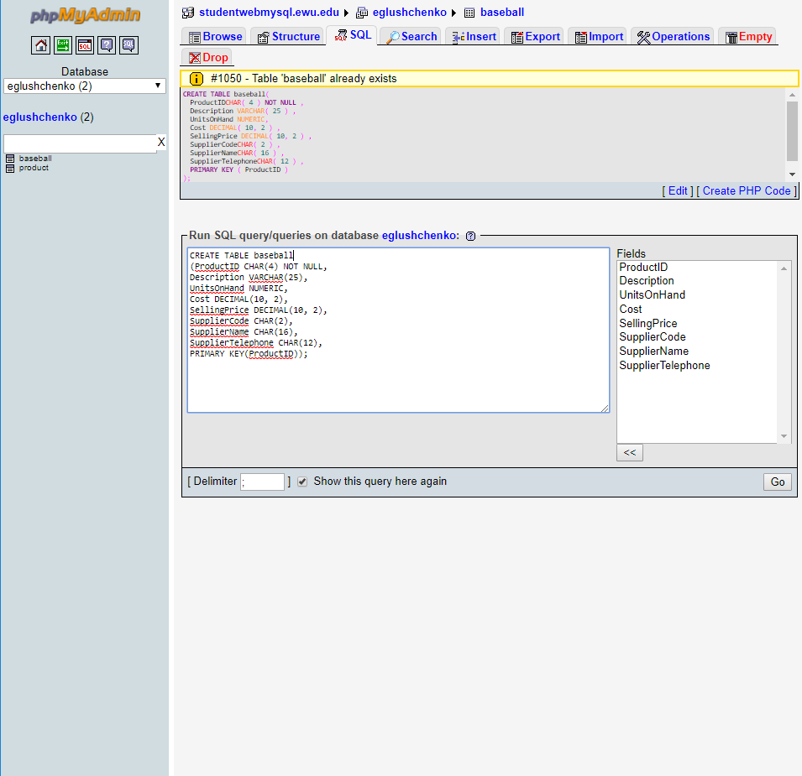

a.

SELECT ItemID, Description, Cost, UnitsOnHand

FROM baseball

WHERE SupplierName="Beverage Holders";

b.

SELECT ItemID, Description, UnitsOnHand \* Cost

FROM baseball;

c.

SELECT ItemID, Description, UnitsOnHand, SellingPrice - Cost AS Profit

FROM baseball

WHERE SellingPrice > 15;

d.

SELECT Description, SellingPrice

FROM baseball

ORDER BY Description, SellingPrice;

e.

SELECT MIN(SellingPrice) AS MinSellingPrice, MAX(SellingPrice) AS MaxSellingPrice

FROM baseball;

f.

SELECT AVG(SellingPrice) AS AVGSellingPrice

FROM baseball

WHERE SupplierCode= "BH";

g.

SELECT COUNT(Description) AS Countitems

FROM baseball

GROUP BY SupplierName;